# Forge Data Exchange(FDX)

**Below image shows how FDX works:**

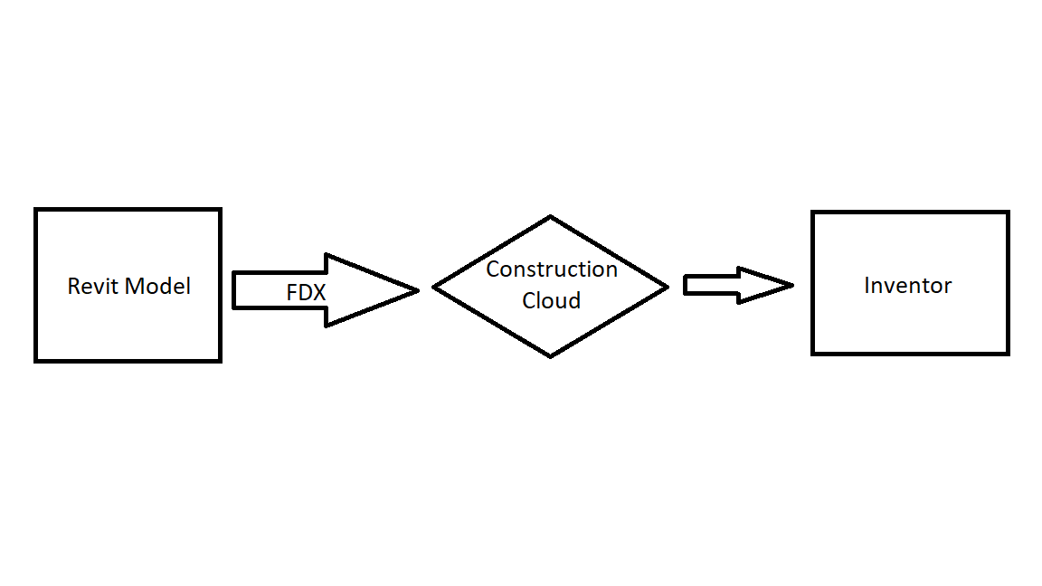

* Architecture shares stairwell dimensions or metadata (wall material properties) with the fabricator.
* We will use FDX to share the subset of data so here the fabricator will receive only the data relevant to their work.

**Work flow:**

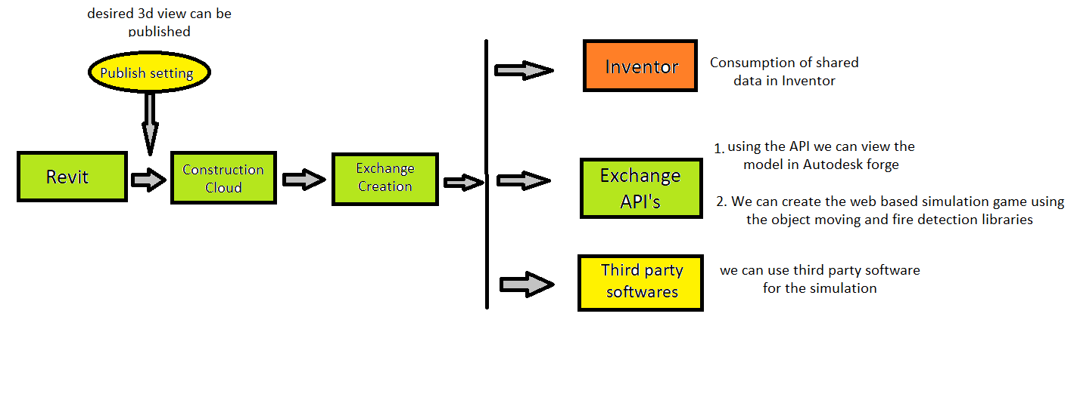

**Third party software:** Done some research on Anylogic Simulator where we can use the Revit model and perform the simulation.

As we will create an interface where we can perform the simulation on a person inside the building to test the fire-rating of the wall.

Below is the link of a video where we can see how Revit model can be used on Anylogic simulator.

<https://www.anylogic.com/resources/educational-videos/integrating-autodesk-revit-with-simulation-modeling/>

**Autodesk Forge Viewer:** we can see the subset data in forge viewer by exchanging API’s.

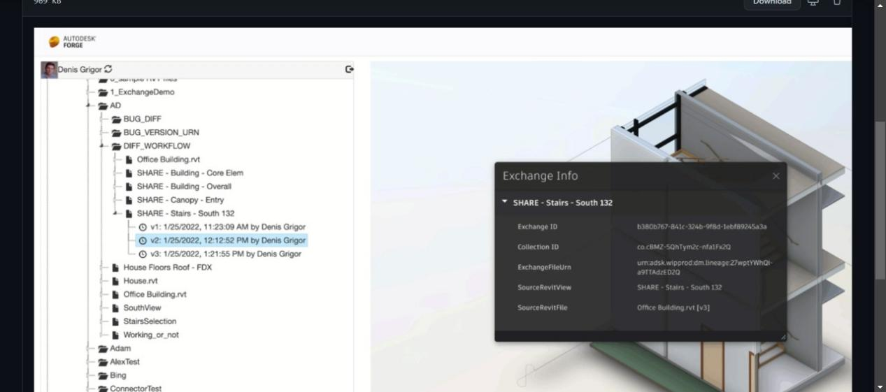

**Publish settings:** we can upload required 3D models in autodesk construction cloud using publish settings. Please check below

